

**City of London Aquatic Services**

Cash Manual

Version: 2016 Summer

Introduction

Welcome to the Team! Our Front Desk/Cashier Staff are an important part of Aquatic Services. You are often the first person a customer sees or speaks with, and as you know – first impressions count.

This manual is designed to assist you with your daily duties, and to help answer many of the questions you may have. The Senior Staff Team at your pool is also available in the event that a customer has a question that you cannot answer.

A good rule of thumb is – “If you touch it, you own it until it is dealt with”. This means if there is a phone message, a customer question, or an item that needs to go into lost and found you are responsible for dealing with it until the problem is solved. Follow up and follow through are key aspects of quality customer service.

If you have any questions whatsoever, please don’t hesitate to contact the Administrative Coordinator (contact information is below).

This manual uses light blue letters to make it easier to find special terms or concepts.

###### Have a great summer!

Aaron Kuhl

Administrative Coordinator – City of London Aquatic Services (226) 919 - 5530

akuhl@london.ca

Table of Contents

Contents

Expectations of Front Desk Staff 4

The Float and Safe 4

Customer Service 5

Tim Dips 6

General Admissions: What We Offer 6

Passes: What We Offer 6

Admission Tracking – Please take note 7

Splashback 8

ACTI-Pass 9

Admission Policy 10

Swim Test Admission Card 11

CLASS 13

Point of Sale (POS) 13

Program Registration 19

Membership Pass Validation 22

ALL PASSES MUST BE PROPERLY SCANNED IN ORDER FOR A PATRON TO SWIM. 22

Printing Class Lists 22

Debit & Credit 24

Integrated Terminals 24

Fixed Terminals 24

Cellular Terminals 25

Registration 26

Cashing-Off Procedures 27

Comparing Totals 28

Over/Short Procedures 28

Robbery Prevention 30

Noticing Possible Counterfeit Funds 30

Robbery/Hold-Up Procedures 30

## Expectations of Front Desk Staff

* Be completely knowledgeable of the information in your job description, the cashier manual, and the policy manual. You are often the go-to person when a customer has a question.
* Only individuals who are cash trained at the summer trainings can assume responsibility for handling money.
* A staff member may not leave cash or related materials in an unsecured area.
* When at the pool, your immediate supervisors are the Pool Manager (PM) and the Assistant Pool Manager (APM). Any questions/problems regarding the pool should be directed to him/her.
* Your actions are a reflection on the Corporation. You should conduct yourself in a professional and mature manner at all times when on duty and on site at the facility.
* Cashiers are not expected to attend the in-service trainings at the pools.

###### Any disregard of the procedures or rules in this manual or the Aquatics Policy Manual is subject to disciplinary actions.

## The Float and Safe

* At the beginning of the summer, a senior staff member will receive a $75 float
  + Thames and Oakridge will receive $150
  + Stronach will receive $125
  + Gibbons will receive $100
* It is the cashier’s responsibility to verify the contents of the float before AND after the shift. Note any discrepancies to your PM/APM.
* When not in use, the float is to be placed in the safe.
* It is the pool’s responsibility to maintain a proper float. Bills can be exchanged for coins at any Scotiabank. Identify yourself as a City of London staff member. The Admin Coordinator will have a float for exchanging money, but this is to be used on an emergency basis only.
* The float is NOT to be used as petty cash, and **should not be exchanged with WaterSmart money under any circumstances.**
* Secure ALL valuable items and personal information in the safe. This is not to be used for personal items of staff members.
* Only the Senior Staff will know the combination of the safe.
* The safe should be locked at all times, regardless of contents.

## Customer Service

Customer service is a key aspect of a cashier’s job. Every customer deserves to be treated with respect.

#### Customers Entering the Building

Acknowledge EVERY individual that enters a facility right away. Staring at a cell phone, a book, or a computer screen is not welcoming for a customer and reflects negatively on City of London staff. A simple “Good Morning” or “Good Afternoon” with a smile can go a long way.

#### Answering the Telephone

Answer the phone promptly with the following phrase: “Byron Pool, Katie Speaking”

If you are unsure of an answer to the question, you can

* + Put the customer on hold, and look for an answer
  + Offer to take the information of the customer and call back as soon as you find an answer

**Refund Policy**

We do not issue direct refunds for admissions. If a customer requests a refund, please direct them to the PM/APM. They will be able to offer a complimentary pass if necessary.

If the City of London cancels a program, a full refund will be issued.

No refunds can be issued after the second class, except in extenuating circumstances.

Administrative fees may be added depending on the situation. Please consult Page 3 in the Spectrum, or call a registration clerk.

### Tim Dips

Tim Dips are free community swims that are sponsored by Tim Hortons.

On Tim Dip days:

* Do not take out the float.
* Tally the number of swimmers on the Tim Dip Tally Form. Email the totals on this form to the Admin Coordinator the next day. The form may then be recycled.
* Print a Drawer Balance Report for this shift and fill out a recap form. **DO NOT** fill out a deposit envelope unless cash was taken in (for pass sales, leadership books etc).

## General Admissions: What We Offer

We offer one-time admissions into our pools. All staff members are expected to be extremely knowledgeable about the Admission Policy.

|  |  |
| --- | --- |
| Indoor | |
| Adult | $5.75 |
| Senior | $4.75 |
| Child | $4.00 |
| Family | $14.00 |

|  |  |
| --- | --- |
| Outdoor | |
| Adult | $4.50 |
| Child | $3.00 |

## Passes: What We Offer

|  |  |
| --- | --- |
| Outdoor | |
| Adult | $95 |
| Child | $75 |
| Family Full Summer | $160 |
| Family July/August | $90 |

|  |  |
| --- | --- |
| **Indoor** | |
| 20 Visit | Adult- $103.50 |
| Senior- $85.40 |
| Child- $55 |
| 3 Month | Adult- $103.50 |
| Senior- $85.40 |
| Child- $55 |

##### Admitting a Pass Holder

1. Assess the patrons using the Admission Policy steps and inform them of the relevant rules or restrictions.
2. Scan the pass into Membership Validation using the scanner. **See CLASS section for more information.**

##### Questions/Answers

###### When are full summer passes valid?

Full summer passes are valid at all outdoor pools from the first day they open. Family half summer passes are valid only in the month they are designated for (July passes can be used for weekends in June).

###### What if a family has more than 4 children?

Contact an Aquatics Supervisor.

###### What if someone loses their key tag?

Simply open that person’s account and issue them a new one. Delete the old key tag.

###### Can someone use their pass for their friend?

No, not under any circumstances can outdoor passes be shared. Any of our 20 visit passes can be shared, with the pass-holder’s permission. With any other type of pass additional swimmers will be charged the admission rates.

###### Can I put my niece/nephew/grandchildren/best friend on the family pass?

Only individuals living in the same household on a permanent basis may be included in the family pass.

**Where can they use their pass?**

Patrons can use their indoor pool passes at any of our facilities, while outdoor passes can only be used at our outdoor locations

###### The pass is coming up as invalid when it is scanned into Membership Pass Validation.

It is the cashier’s job to investigate where the error has occurred. First, check to see that the pass number matches up with what it on the account. If that is the same, check to see what type of pass they have (if any). If there is an issue, talk to your PM/APM or call the Admin Coordinator to walk you through solving it.

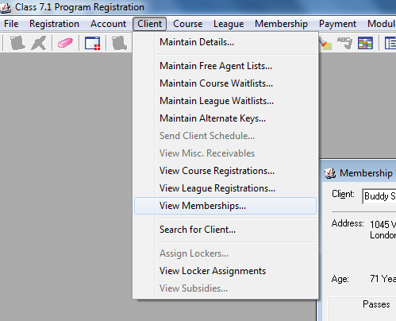

## Admission Tracking – Please take note

It is extremely important that every individual that goes onto the deck or into the pool is tracked. If the **individual is swimming**, they will be inputted by:

1. General admissions (each individual will pay for their admission into the facility)
2. Membership scanning through Membership Pass Validation (see note below) If the **individual is not swimming**, they will be admitted by:

1. The “Parent (not swimming)” button in POS. This is to ensure that swimmers who do not meet the age requirements of the admission policy can be supervised without the supervisor having to pay admission. These individuals must still be tracked because they count toward the bather load (whether swimming or not).

Note: Every individual swimming with a membership pass must be scanned and verified at the front desk. You **MUST** watch membership pass validation to ensure that valid passes are being scanned. If there is a problem with a pass, cashiers are required to investigate the reasons behind the invalid pass. Please ask your PM or APM for assistance.

# Splashback

This is an offer for customers who come in the afternoon to swim in the evening for the reduced price of

$2.00 per person. The pass is only valid for the **SAME** day and at the **SAME** pool. Inform every paying customer of this promotion when they enter the pool.

###### Distribution:

1. Ensure stamp is set to the CURRENT date. Stamp back of pass.
2. Write in the number of children and adults that were in the transaction.

Please inform Aaron when you run out of these cards, as a new process will be implemented.

###### Admittance:

1. Read the back of the card. This is the maximum number of individuals allowed to be admitted for $2 per person. All other admissions will need to be paid through regular prices.

ie. If card says 2 adults and 3 children, but there are 3 adults and 2 children, admit 4 under Splashback, and 1 adult under regular admissions.

1. Write “VOID” on back of pass, and staple to balancing at end of shift.



# ACTI-Pass

###### What is this program?

###### The ACTI-pass program is an initiative that aims to promote physical activity for Grade 5 students within the Middlesex-London area. This is accomplished by providing FREE access to recreational programs with their partners.

###### How do they join?

###### Students receive a hardcopy of the registration package through their school prior to starting their Grade 5 year or they can apply online on the In-Motion webpage.

###### How does this impact us?

###### City of London Aquatic Services is one of the ACTI-Pass partners. This partnership entitles the ACTI-Pass cardholder to free admission to any of our recreational swims throughout the year. In addition to the cardholder’s admission, this pass also grants an additional +1 admission.

###### 

###### What are we required to do?

After completing the registration process the client should receive this card.

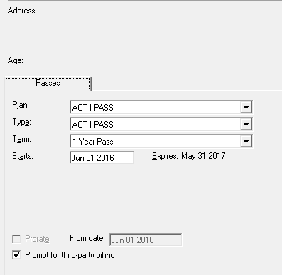

After showing any City of London pool this card, complete a pass registration for the client as discussed on page 18. There is an option under plan type for ACTI-Pass. They should also be issued a key tag ID.

###### After receiving this key tag the ACTI-Pass owner can use this key tag for their own admission as well as a +1. This +1 can be used for either a parent or friend, and it is rung in as a complimentary pass in Point of Sale. Please note that normal admission policy and all other requirements are still in effect.

# Admission Policy

The majority of the responsibility of this policy falls on the cashier. It is imperative that customers who do not meet the requirements of the policy are recognized before being admitted into the pool. Under no circumstances should staff be lenient on this policy.

Patron arrives to swim at any City of London aquatic facility. If they are 17 and under they will automatically be banded.

###### Age 0-12?

**Age 13-17?**

Considered a ‘Responsible Person’ (lower risk) and is automatically banded with a **green hashed band.**

Considered a ‘Non- Swimmer’ (higher risk) and is automatically banded with an **orange band.**

###### No swim test or unsuccessful swim test?

**Must be directly supervised in the water (within arms’ reach)** at all times by a responsible person 13 years of age or older. These individuals are restricted from using diving boards, slides and other equipment located in the deep end of

**Successful completion of the swim test?**

**Orange band** will be

removed and replaced with a **green hashed band** allowing full facility access.

**These individuals still require direct supervision within the facility** by a

responsible person 13 years

**Leaving the**

**facility?**

Cashiers can issue **Swim Test Admission Card** if requested by an individual as they leave the facility. **Please note: Cashiers should only be issuing cards to individuals with the bands STILL ON THEIR WRISTS**. If they are merely holding it a card will not be given out (they could have just picked it up off the ground). If you are unsure please seek clarification from your PM/APM/Deck Supervisor.

## Swim Test Admission Card

The Swim Test Admission Card is available to swimmers who have successfully completed a swim test. These individuals will be able to be issued a green wristband when entering the pool.

Cashiers may give out cards ONLY if the swimmer has a green wristband securely fastened on their arm.

Fill out the information in permanent marker. The ‘Verified By” portion will be the name of the staff member who is issuing the card (ie. If a cashier is filling out the card, the cashier will write their name).

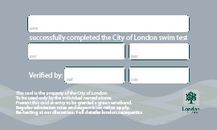

#### Codes:

##### What is your favourite type of ice cream?

Example: 1CH = Chocolate 1MNT = Mint 1CD = Cookie Dough

1. **What is your favourite colour?**

Example: 2GR = Green 2NOR = Neon Orange 2GY = Grey

#### Supervision Ratios

The following supervision ratios are used for children with wristbands:

*** RP = Responsible Person (aged 13+)

**Orange Wristbands:**

Without Lifejackets: 1 RP to 2 children With Lifejackets: 1RP to 4 children

**Green Wristbands:**

Without Lifejackets: 1 RP to 4 children With Lifejackets: 1RP to 8 children

If a family has more than one type of wristband, the lower ratio applies

#### Problem Solving

The goal of the admission policy is not to restrict patrons from enjoying our facilities. It was enacted to help provide a fair assessment of swimming abilities in order to create a safe environment for both patrons and staff. If an individual finds that they do not meet the admission requirements, attempt to provide them with a solution.

###### The swimmer is under 13 and cannot pass the swim test. The parent that brought them did not bring a bathing suit.

Unfortunately, this individual cannot be left unsupervised. The parent could go home and get a bathing suit (and pay admission) or find a friend/family member who is 13+ to watch the child.

###### A parent has three children. All are under 13 and cannot pass the swim test.

The parent can still bring the children into the pool, however all three will be required to be in life jackets.

# CLASS

CLASS is the system run on the computers to input admissions and register for passes and programs. To log on, open Central Login and input your username and password. These are three main programs in CLASS that you will be using:

1. Point of Sale (POS)
2. Program Registration
3. Membership Validation

## Point of Sale (POS)

POS is the program within CLASS that is responsible for accepting the customer’s payment. The majority of the use of this program will be for general admissions.

#### Entering a Sale:

* 1. Ensure that the customers meet the admission policy PRIOR to entering the transaction
  2. Enter the types of admissions (ie. 2 child passes, 1 child admission, and 2 adult admissions)
  3. If paying with cash, enter the payment. If the customer passes you a $20 bill, press “20.00”
  4. Press the appropriate form of payment (cash, debit, VISA, etc.). If using a non-integrated debit/credit terminal, go to the **Debit/Credit section**
  5. Provide them with their change (if applicable) and proceed to issuing wrist bands

#### Crediting an Account:

1. Perform a client search using the “**Client Search**” button in the upper left corner
2. Click “**Credit Account**”
3. Enter the amount that the customer would like to put on their account (ie. the cost of a set of lessons)
4. Tender the transaction (with cash, debit, etc.)

#### Paying for Admissions with an Account Credit:

1. Perform a client search using the “**Client Search**” button in the upper left corner. This should pull forward any amount that is on the account.
2. Enter the admissions (adult, child, etc.)
3. If there is additional credit that is not used, click “**Balance on Account**”. If they owe more money than is on their account, proceed as a normal sale.

#### Admitting Camps

There are 4 types of camps that may come to swim:

1. A City of London camp – will have rubber bands and councilors with COL t-shirts
2. A City of London playground – councilors will identify the camp as a playground
3. A non-City of London camp with an pre-credited account balance to be used for admissions
4. A non-City of London camp without a pre-credited account balance wristbands – will pay regular admissions

###### The first two groups above will be inputted through LOOKUP CAMPS in POS.

Ensure that each swimmer has a wristband on. Input the number of campers swimming.

Input the number of leaders swimming. Input the location of the **POOL.**

Input today’s date.

The total for this transaction should be $0. Input leaders or campers who aren’t swimming as “Parent (Not Swimming)” in POS.

Camps who are not operated by the City of London will pay regular admission for their campers. Leaders will be admitted free-of-charge.

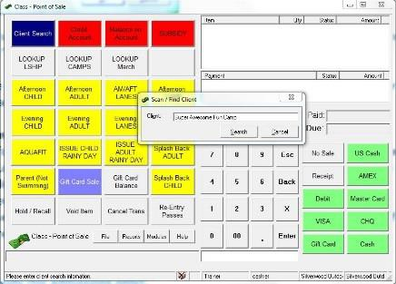

###### Paying for a Camp with an Account Credit:

1. Perform a client search using the “**Client Search**” button in the upper left corner. This should pull forward any amount that is on the account.

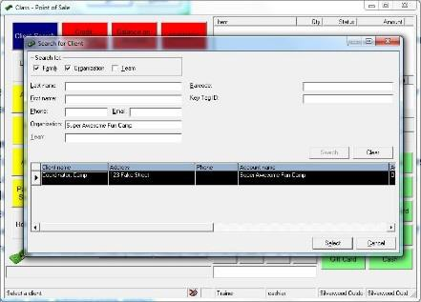You will need to ensure that the application is searching for an

###### Organization.

1. Enter the admissions (adult, child, etc.)

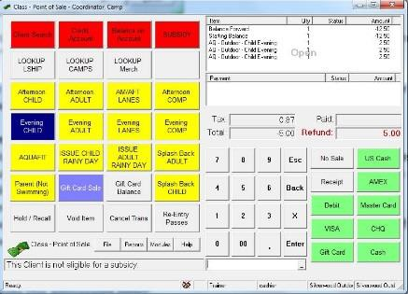

1. If there is additional credit that is not used, click “**Balance on Account**”. If they owe more money than is on their account, proceed as a normal sale.

#### Paying with Subsidy (for admissions only):

Starting January 2014, all cashiers are able to apply a customer’s Parks and Recreation subsidy to a transaction such as a recreational swim, lane swim, or aquafit admission. Previously, subsidy could only be used for registrations and memberships. **Subsidy is like our memberships. People may NOT share subsidy. The only time where you may use one person’s subsidy for multiple people is if a parent wants to purchase a family admission. Otherwise, you must repeat this process for each person. Subsidy for memberships should be directed to the registration clerks.**

1. Open POS. Press the red “Subsidy” button.
2. Search for the client using their name, phone number, or client ID
3. Click the admission type that you wish to sell (ie. Adult Rec Swim). An “Enter Subsidy Amount” box will come up. Customers have a maximum of $300 per year that can be used for subsidy. If they have more available subsidy than the cost of the admission, then the max subsidy will be the admission cost. You may subsidize all or part of the admission.
4. To complete the transaction, click Balance on Account.

#### Cheques

Cheques can be made out to the “Corporation of the City of London”. All cheque are to be stamped on the back and placed in the cash drawer. The cheque number is the 3 digit number on the top of the cheque.

#### Manual Cash

If POS stops working, use the manual cash sheet to keep track of transactions. Unfortunately, memberships cannot be sold when the computer system is unavailable. Customers can call into the registration line to have them processed on the spot. Key tags can be issued when the computer is functional. Items tracked on the manual cash sheet should be entered as soon as the computer is functioning – consult the Admin Coordinator if the computers aren’t operational until the next day. If a receipt needs to be issued, take down the contact information (address and phone number). A receipt can be mailed out next-day when CLASS is active. Alternatively, a manual receipt can be processed by the Admin Coordinator and mailed out. Please inform the Admin Coordinator of any receipt issues.

Keep one copy of all debit/credit receipts.

#### Pool Leader Shirts

Pool leader shirts can be sold by any CLASS trained staff member. Please enter into POS using the following steps.

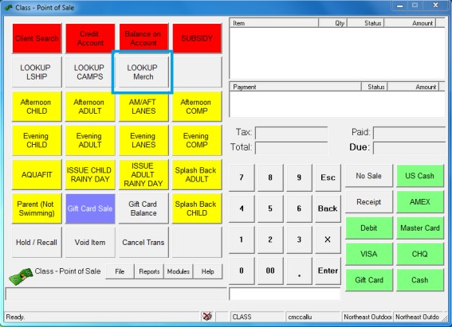

Press “**LOOKUP Merch**” in POS.

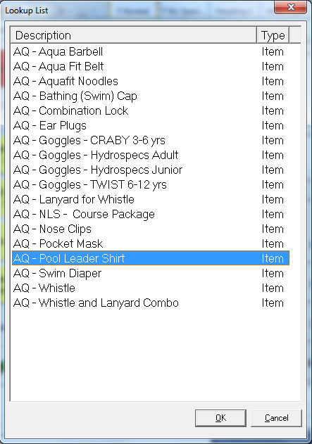

Click on “**AQ – Pool Leader Shirt**”. This will bring it into POS.

Enter the name of the pool leader and the pool that they are currently at.

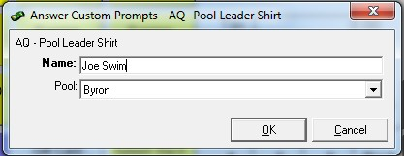

This will enter a $5 transaction into POS.

#### Complimentary Passes

Comp passes are given out at the discretion of the PM or APM. Passes are only to be distributed to customers who have been swimming for **less than an hour.** Complimentary passes will be distributed by printing off a comp pass on the computer

Thunder and lightning are not automatic claims for a pass – a pass should only be given out if the thunder/lightning is continuous and shows no signs of stopping before the end of the swim. If it looks like it will blow over, kindly ask the patron to wait for a few minutes.

Pool fouling will use the same process, unless liquid. Customers who have been in the water for less than an hour may receive a pass.

###### Distribution (see steps on diagram):

1. Select the type of comp pass being distributed (adult or child).
2. Press “Cash”.
3. Press “Receipt” – this pass is valid for the summer of 2015 at any outdoor pool.

You can print a separate comp receipt for each admission, or combine multiple admissions on one comp receipt. This should be the customer’s preference.

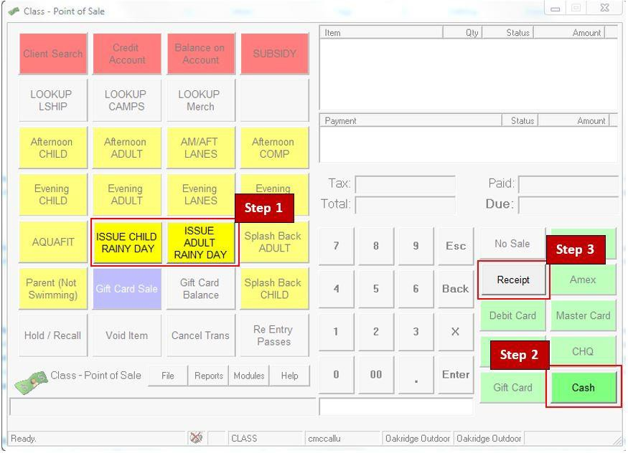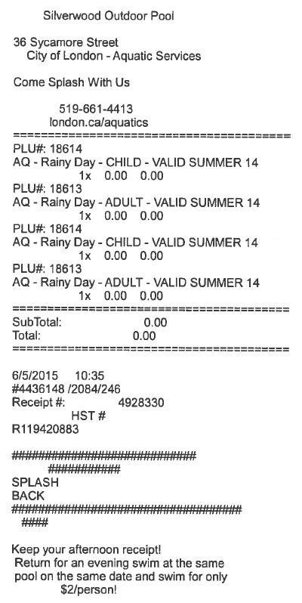

###### Admittance:

1. Check to ensure the pass is valid (correct type and expiry date).
2. Press “Comp Pass” in POS, then “Cash”.
3. Write “VOID” on the pass, and staple it to your balancing at the end of the shift.

## Program Registration

Program Registration contains two sub-programs: “Program Registration” and “Membership Pass Sales”.

Cashiers and PM/APM’s will not be able to register individuals for courses using Program Registration. Customers may register online or with a registration clerk. However, passes can be sold using Membership Pass Sales. This can be accessed by opening Program Registration.

For information on assisting with **registration for program**, please see page 24.

###### Selling a Membership Pass:

1. **Sell the pass as if it were a regular membership from Program Registration**

All passes are under the plan “**Aquatics Outdoor Summer Pass**”



1. ***If you are selling a family pass, skip to step 3.***

**Select either Adult/Child, and then Full Summer as the term.**

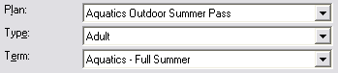

*Skip to Step 4*

1. **For a family pass, you need to create a membership for each person. Start by issuing the pass under the main contact.**

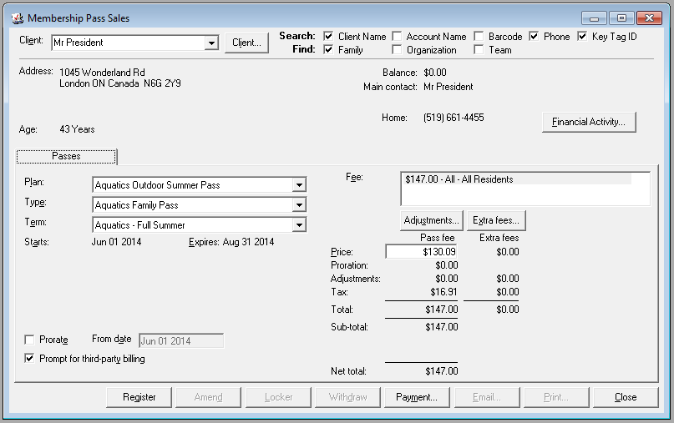

A family pass can be issued to up to six people (2 adults, 4 children). You can also choose a term (July or August).

1. **Click Register.**
2. **Select the individuals on the account who will be getting a pass. Please note the requirements**.

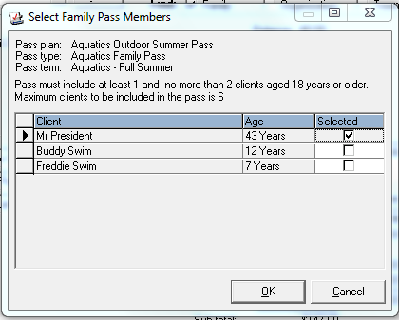

1. **Assign the key tag as an alternate key.**

Click on Client > Maintain Alternate Keys

Scan the pass into the Key Tag ID field. **Ensure that you are accurate; there is zero ability for there to be any errors in this step.**

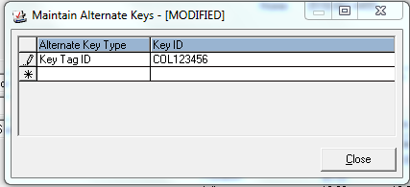

**Note: Key tags** are used to link a person to their account. The actual membership is located on their account. Therefore, if they lose their key tag, simply remove ALL old “Key Tag ID” numbers, and issue them a new one. The old key tags will not work. No person should have more than one active key tag on their account. This will eliminate the possibility of someone else using their pass, intentionally or not.

1. **Take a photo for each individual**

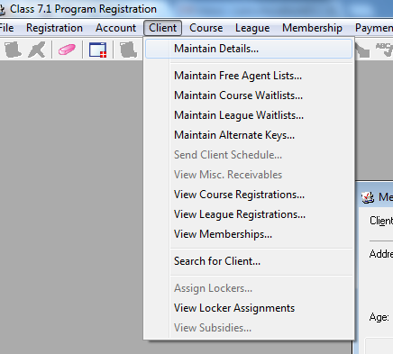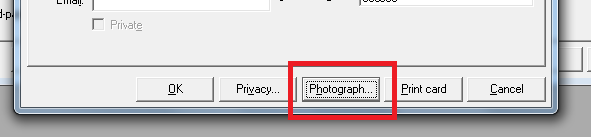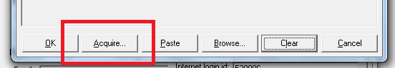

Client > Maintain Details > Photograph > Acquire

Ensure that the individual is visible in the photo. You can crop the photo to ensure that the head and shoulders are visible. If it is a younger child, the parent may hold the child up to the camera. All individuals **MUST** have a photo.

1. **Take Payment**

Press “Payment” in the Membership Pass Sales window. This will automatically direct you to POS.

#### Issuing a Pool Leader Pass

Pool leader passes are issued to pool leaders who have successfully completed one week of the program. Cash-trained staff will be instructed to issue a pass by the Senior Guard. Fill in the customer and pass information, but before pressing “Register”, press “Adjustments”. Select “Aquatic Pool Leader” from the drop-down list. This will apply an adjustment of 100% to the pass. **Ensure that the Net Total for the transaction is $0 before pressing “Register”.**

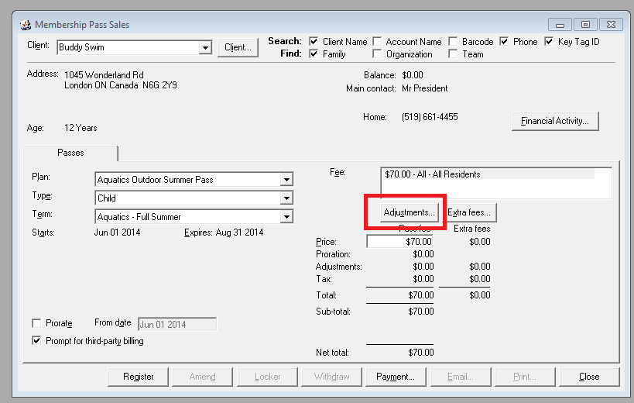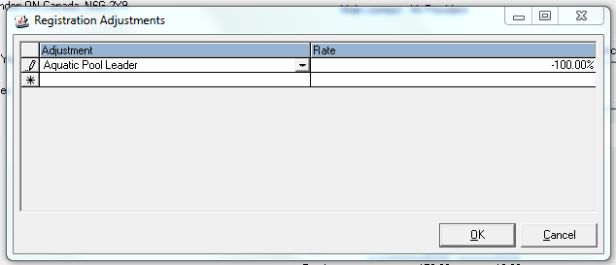

#### Searching for a Course

The other usage for Program Registration is to look up barcodes for courses. You can see the number of participants registered and the class list. It is important that the names of individuals on the class list are not given out to anyone other than staff.

You can search for a course by inputting the barcode (found in the Spectrum catalogue) into the search bar. This will allow you to see the course information, including the number of people registered and the number of spots available.

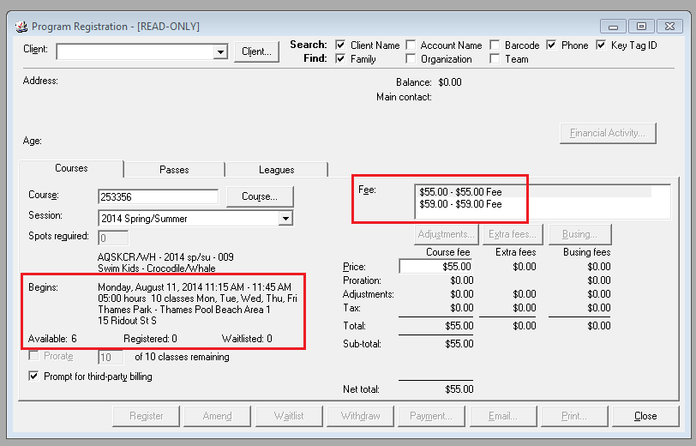

More information can be found under “Course”.

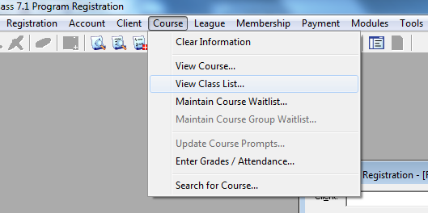

## Membership Pass Validation

Passes must be validated before a swimmer enters the pool. Scan the barcode on the back of the pass into the Membership Validation program located in Central Login. The picture on the account must match the individual. Passes are not transferrable, and cannot be used by anyone other than the pass holder. If you are suspicious, ask for additional information, such as a birth date or postal code. If you suspect someone is sharing a pass, please consult the PM/APM.

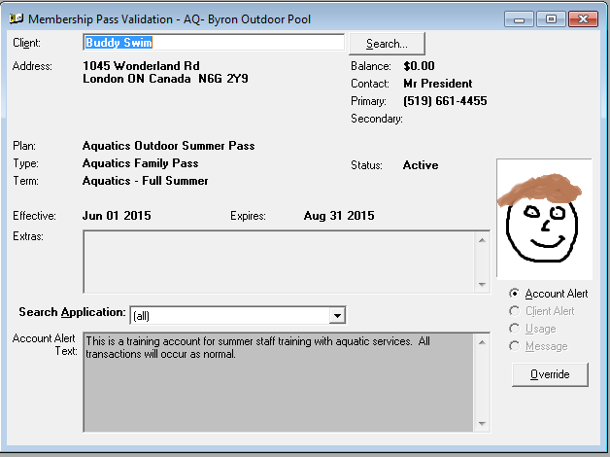

Ensure the type of pass is valid for the summer

Ensure the pass is being used by the correct person

Ensure the MPV is searching “(all)”

## ALL PASSES MUST BE PROPERLY SCANNED IN ORDER FOR A PATRON TO SWIM.

If a pass is not scanning properly into Membership Pass Validation, you should try to troubleshoot the problem by looking up their account. Write down their pass numbers and call the Admin Coordinator if you cannot find a solution. It is imperative that EVERY swimmer be tracked through our systems.

## Printing Class Lists

Class lists are printed using “Report Printing” in Central Login.

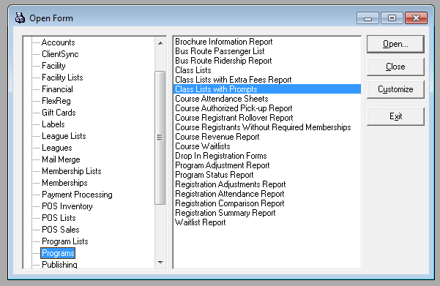

Under the “**Programs**” section, select “**Class Lists with Prompts**”.

You will be printing class lists for the entire session at your pool.

**Session:** Always 2014 Spring/Summer

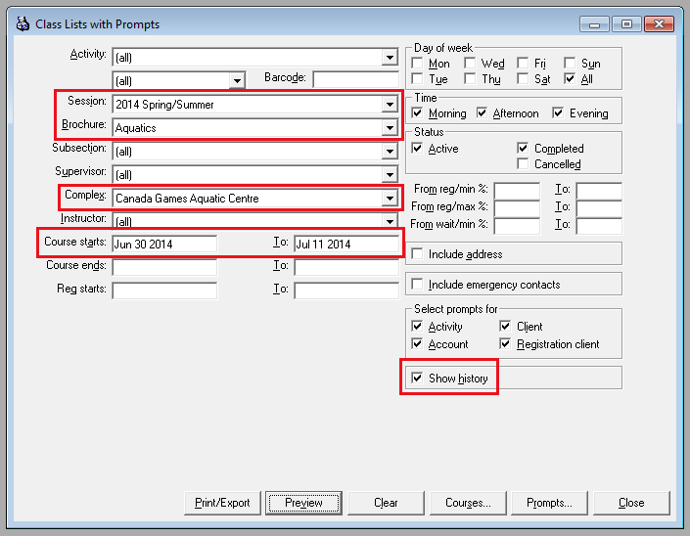

**Brochure:** Always aquatics

**Complex:** Will be your pool

**Course Starts:** This will be from the first day of your earliest course in the session, until the last day of the latest course in your session.

###### Ensure that “Show History” is checked off.

Alternatively, you can print individual class lists by inputting the barcode.

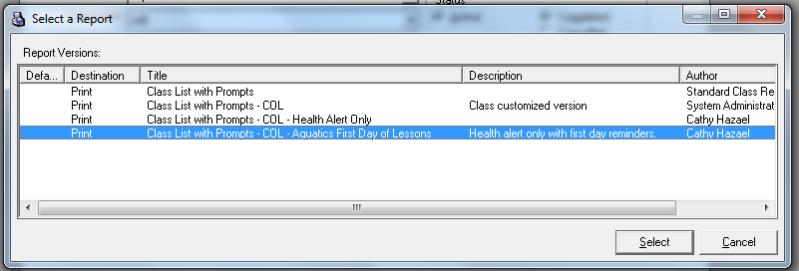

Press “Print/Export” and select the option that is highlighted in the picture.

# Debit & Credit

There are three types of debit/credit terminals at our outdoor pools. They are:

* 1. Integrated – Thames, Oakridge, Stronach, Glen Cairn
  2. Fixed – Byron, East Lions, Gibbons, Northeast, Northridge, Silverwood, Southcrest, Westminster
  3. Cellular – Thames

## Integrated Terminals

These pin pads are connected to the PCs and communicate directly with CLASS. To initiate a debit or credit transaction, press the appropriate tender type in POS and follow the prompts on the screen.

If you find that a pin pad is not operating properly, open the “Pin Pad Re-initialization” program located on your desktop. Follow the steps in the program to reinstall the software on the pin pad. If this process does not work, please contact the admin coordinator for further instruction.

## Fixed Terminals

These pin pads cannot leave the front desk and do not communicate with CLASS.

#### Entering a Sale:

1. Enter the admissions/sale into POS. DO NOT press a tender type yet.
2. On the pin pad, press “**Sale**” and enter the amount that is stated in the “**Due**” box in POS.
3. Press “**OK**”. Pass the terminal to the customer.
4. Once the transaction has been approved, press the correct tender type in POS.
5. Keep the merchant copy. Give the customer the other copy.

#### Settlement:

At the **end of the shift**, the terminal must be settled (cleared). Attach the report to your balancing.

1. On the main screen, hit “**Settlement**”. A pre-settlement report will print out.
2. Press “**OK**”.
3. Staple both reports to the balancing for that day. Ensure the totals for each type match what is on the Drawer Balance Report.

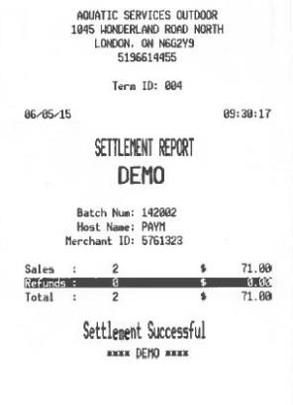

The settlement is only complete when you see “**Settlement Successful**” at the bottom of the printout. If you do not see this, please repeat the steps.

## Cellular Terminals

These pin pads are cellular and portable. They also do not communicate with CLASS.

#### Entering a Sale:

1. Enter the admissions/sale into POS. DO NOT press a tender type yet.
2. On the pin pad, press “**0**” and enter the amount that is stated in the “**Due**” box in POS.
3. Press “**OK**”. Pass the terminal to the customer.
4. Once the transaction has been approved, Press “**OK**”.
5. Press the correct tender type in POS.
6. Keep the merchant copy. Give the customer the other copy.

#### Settlement:

At the **end of the shift**, the terminal must be settled (cleared). Attach the report to your balancing.

1. On the main screen, hit “**8**”. Press “**Yes”**.
2. Press “**YES**”.
3. Staple both reports to the balancing for that day. Ensure the totals for each type match what is on the Drawer Balance Report.

# Registration

The cashier’s role is to provide information and answer customer questions about courses and registration. Although cashiers will not be handling registration, it is vital that they are knowledgeable about the programs offered at their facility.

See the “CLASS” section on searching for course information. Alternatively, you can search in the Spectrum catalogue to find times, barcodes, and prices.

For registering, customers can either go online or call/visit a registration clerk.

#### Online:

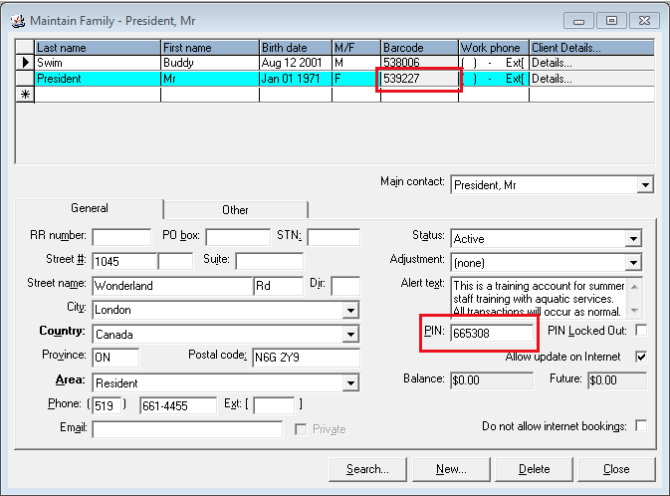Customers will need their **Family PIN number** and the **Main Contact Client ID** (barcode) to register online. To find this information, open Program Registration > Account (top heading) > Maintain Family. The main contact for the family account is always highlighted in bright blue. Fill out this information on a **Customer Information Card**.

Customers can access their account at [www.london.ca/spectrum](http://www.london.ca/spectrum) using the Family PIN and Main Contact ID.

#### With Registration Clerk:

Customers can call the **registration line** (519-661-5575) and register using their credit card, or go in- person to see a clerk at the following facilities:

* Carling Heights Comm. Ctr.
* North London Optimist Comm. Ctr.
* Market Tower
* South London Comm. Pool
* Kiwanis Senior Comm. Ctr.

The registration clerks are only available from 8:30am – 4:30pm, Monday through Friday.

Customers can choose to credit their account if they would like to register online, but pay with cash or debit. This is similar to pre-paying for the course. See the CLASS section (under POS) for more information.

# Cashing-Off Procedures

###### End of Shift – Cashier and Manager:

1. Print a drawer balance report from POS. Count out the float from total cash, and place the remaining money into a cash envelope.
2. Ensure drawer balance cash total matches the flap from the cash envelope.
3. Settle the debit/credit terminals (if applicable). See page 23.
4. Fill over/short report if required.
5. Staple together, in this order, from top to bottom: Cash envelope flap, receipts, drawer balance report, and over/short report (if applicable). Place in balancing folder.
6. Place float and cash envelope in the safe.
7. 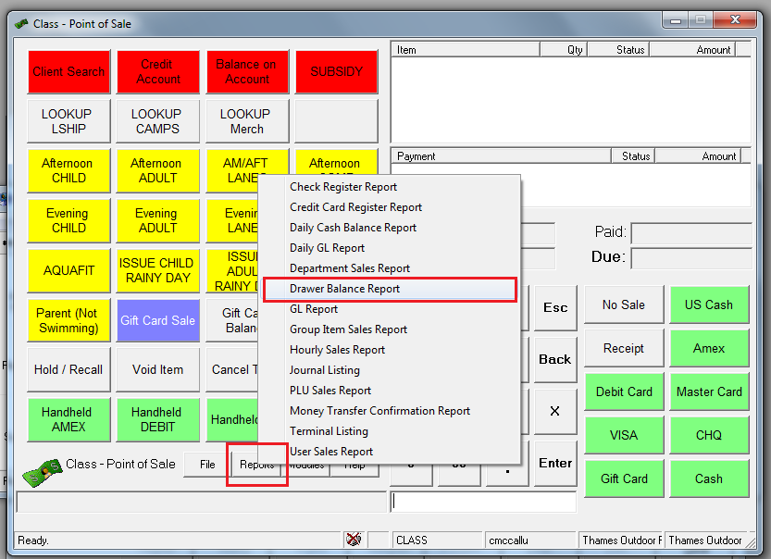**Ensure that the cash drawer is left open**. In the case of a break-in, we would rather have people know that there is no money, rather than trying to break into it.

A Drawer Balance Report can be printed in POS.

Report > Drawer Balance Report

*Cash Envelope Flap*

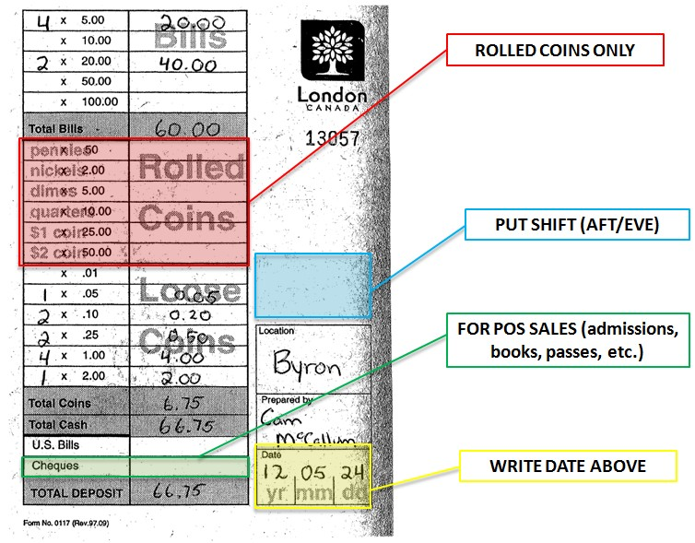

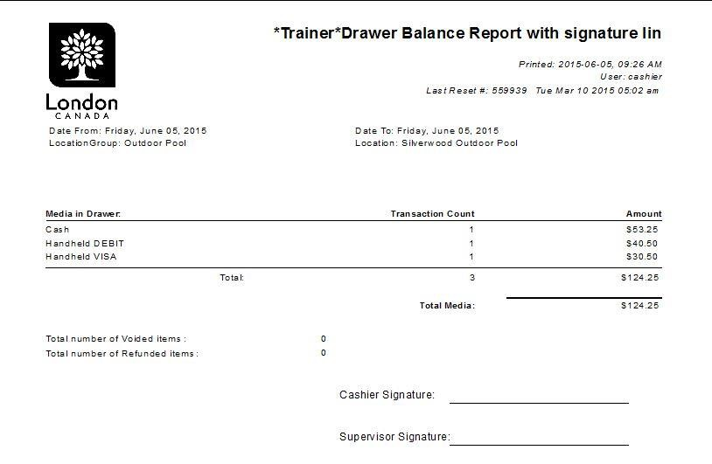

## Comparing Totals

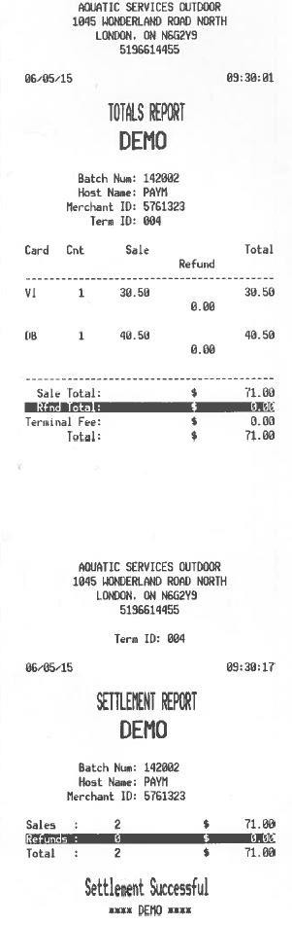

All of the totals from your drawer balance report should match the amount of money you have received, either through cash or electronic payment. If there are discrepancies, see the section below.

## Over/Short Procedures

It is extremely important for all front desk staff to be precise when handling cash. Overages and outages are not acceptable on a routine basis.

Pool managers are expected to clear over/shorts before the day’s end. They are then **REQUIRED** to inform the Admin Coordinator of the issue. Pool managers: See Supervisory page for more information.

Should a problem occur, and the issue cannot be cleared, please follow the procedure below:

**YELLOW**

Less than $5

* Recount Float and Deposit
* Write descrepancy on recap form

**ORANGE**

Less than $10, more than $5

* YELLOW, plus:
* Fill out an over/short report

**RED**

More than $10

* ORANGE, plus:
* Call Admin Coordinator asap (leave a message if not answering)

If overages/outages become an ongoing problem, the Admin Coordinator will assess the situation and implement additional training and/or take disciplinary action. Ongoing development is a key aspect of any front desk job. Please ask for additional training if you are worried about possible overages/outages.

## Robbery Prevention

* Greet each patron as they enter the facility.
* If you see someone loitering around the facility, politely ask if they require assistance.
* Keep active and alert – be observant of all activities, both inside and outside your facility.
* Do not count cash in public view.
* Pool staff should be suspicious of any person who asks questions about security or cash handling. Do not disclose any information. Report any suspicious activity to the PM/APM and Administrative Coordinator immediately.
* Do not disclose the responsibilities or schedule of the Administrative Coordinator to members of the public. Should anyone have any questions or concerns, please forward them to an Aquatics Supervisor. The Admin Coordinator will be picking up funds at irregular times daily so as not to set a pattern for a potential robber.

## Noticing Possible Counterfeit Funds

* Cashier will notify the PM/APM on duty, who will then call the police using the non-emergency line.
* Obtain the name, address and phone number of the customer.
* The cashier should not return the money to the customer. Inform the customer that the City will take possession of the counterfeit money. If the bill is genuine, it will be returned to the customer in full.
* If the pool staff cannot obtain the contact of the person submitting a counterfeit bill, they will need to get a description of the customer as well as vehicle information.

## Robbery/Hold-Up Procedures

* The overriding concern during/after a robbery is for the safety of the staff members and the safety of the patrons within the facility.
* Stay as calm as possible.
* Follow the directions of the robber to the best of your ability without endangering yourself or other patrons.
* Do not argue or attempt to disarm the robber.
* Advise the robber of any other staff/customers in the facility to avoid startling them.
* Any noted passed to a staff member will be kept and only handled by the edges.
* Observe the robber carefully – note any unique features.
* Remember any place that the robber touches so that police can check for fingerprints.
* Staff member(s) will not attempt to overpower the robber.

After the incident:

* Call police immediately.
* Once the robber has left, lock all doors and attempt to preserve any evidence.
* Note a description of the robber, their means of transportation, and the direction they travelled (if it is safe to do so).
* Witnesses should be asked to wait until the police arrive. Do NOT discuss the incident with any witnesses or staff members. Please wait until the police arrive.
* Call the Manager/Supervisor of Aquatics as soon as possible and do not speak to the media.